Project Template : A Gamified Mobile Application for Local Disaster Preparedness and Response

# 1. Introduction: Concept, Motivation

Changes in climate as a result of increasing CO2 over the past decades has increased natural disasters

Making disaster preparation more crucial than ever (Rubin 2012) and as the number of disaster increases

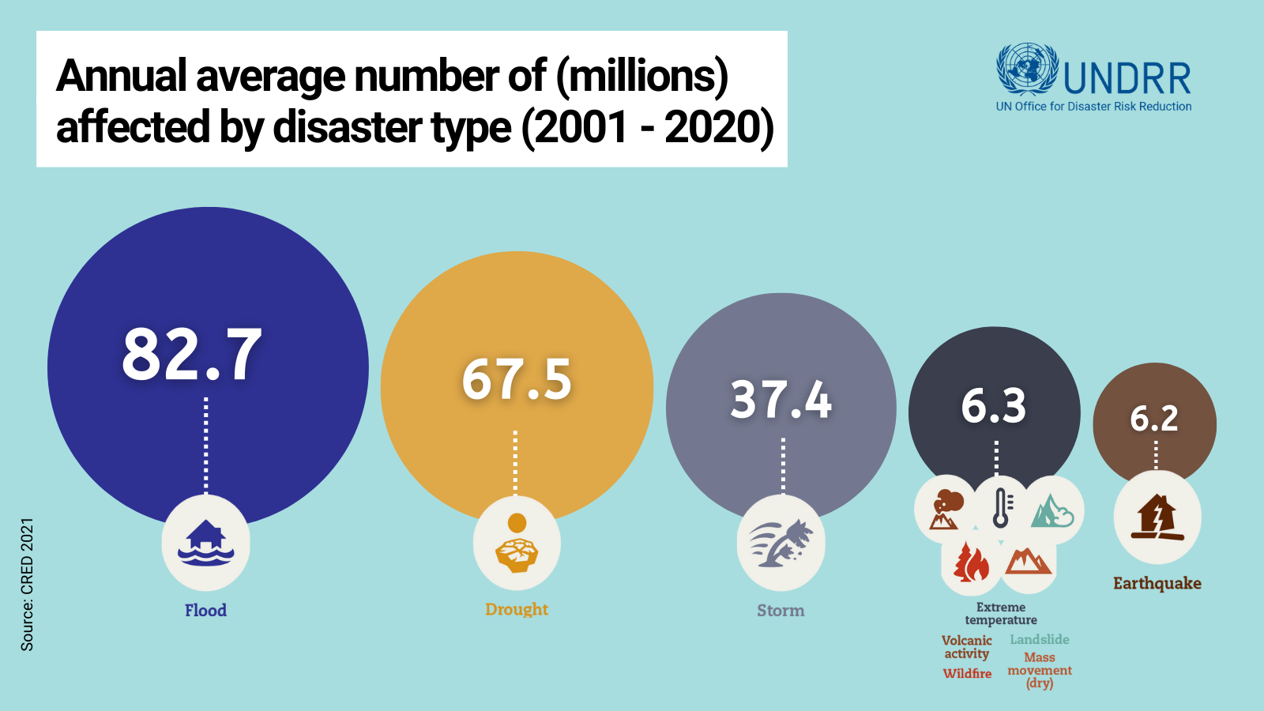

UNDRR 2020, undrr.org

Preparation during disasters is now more than ever critical.

Unpreparedness can overload Emergency services,overburden hospitals and reduce economic, personal and financial loss, even crippling whole local communities, and this has been seen to happen to many different communities globally

|  | Disasters in 2012 alone cost close to 600 Billion USD, not accounting for casualties, losses in opportunities and more  Picture source:  *Statistica 2021: The Cost Of 21st Century Natural Disasters* |
| --- | --- |

| And time and time again, preparation has been proven to reduce death tolls  Yet why is there a lack of it?  *Source Statistica 2021: Preparedness Drives Down Natural Disaster Death Tolls* |  |
| --- | --- |

| *2025 Collidu: Disaster Management* | The problem is that there are still many individuals that experience disasters unprepared due to inefficiencies in today's disaster preparation heuristics.  Preparation methodologies such as pamphlets and static websites have been shown to be an inefficient medium of educating preparedness and even worse a |
| --- | --- |

The objective of this project is to analyse, study the problem, risk and consequences with lack of preparation, and implement solutions to mitigate existing problems, to help save lives and reduce losses

## 

## 

## 1.1 Problem Statement

## 

| **Low Engagement** | **Information Fragmentation** |
| --- | --- |
| People think preparation is   * Burdensome * time consuming * low priority | * Critical reaction time * Need consult with different fragmented, generic sources of information |

| **“Amotivation”** | **Consequences** |
| --- | --- |
| Current approaches   * Static PDFs & websites * Pamphlets * AI Chatbots   Issues   * Cognitive overload * Information is Inspiring, passive * Badly formatted * No social reinforcement and feedback loop | When there is a lack of preparation due to it being seen as “low priority”   * Overloaded Emergency services and hospitals * Increased financial, personal losses |

## 1.2. Aims and Objectives

To create, develop, and test a mobile application prototype called "Rally," using gamification, measurably boosts user engagement in disaster preparedness and acting as an accurate & reliable lifeline

Objectives:

| **To Establish a Theoretical Market Foundation** | **Ensure Ethical project** |
| --- | --- |
| * Identify proven methods * understand and utilize motivational mechanics * Gain understanding of motivation mechanics thorough literature reviews | Design a high fidelity UI around user-centered methodologies and to proven conventions in HCI theory |
| **To conduct a Functionality analysis** | **Ensure Ethics** |
| Analyze, validate   * functional gaps * Offline capabilities * real time alert functionality with gamification * Conduct competitive analysis of existing apps | Conduct and analyze risks to users and the mitigations |

| **Develop a Functional 3 Pillar MVP**  **(Development)** | **To Assess the Prototype's Effectiveness**  **(Testing & Evaluation)** |
| --- | --- |
| The creation, development of the gamified “Prepare” module  The “Prepare” module will   * employ checklists * progress bars, points   To encourage and motivate preparation  Development   * Create an app with offline functionality   Integration   * Incorporate “Live Alerts” * Receive, display location based * Real time alerts from trusted APIs | * Assess "Response" module's effectively * Enable high speed and clarity in a high-stress scenario * To collect quantitative and qualitative data to determine & justify gamification * Creation of final analysis and report for prototypes’s feasibility * Performance assessment |

### 1.3 Ethics Audit: Mobile App for Local Disaster Preparedness

Ethics audits assess viability of the proposed project from an ethics perspective. I concluded that this project is ethically viable with caveats

**Key Ethical Risks Identified:**

| **High risk** | **Medium Risk (privacy)** | **Low risk** |
| --- | --- | --- |
| Harm to users from psychologically | No direct harm, possible indirect harm | Low to no indirect harm to users |

#### **1.3.1 Risk Area: Safety-Critical Information & Technical Failure**

This is the most significant ethical challenge for the project.

| **Risks** | **Implications** | **Severity Level** |
| --- | --- | --- |
| Misinformation | The app provides   * outdated, inaccurate, information like dangerous, obstruction evacuation routes, shelters, or wrong emergency contact information during emergencies | 3 |
| Network Latency | Especially devastating in time critical disasters like flash floods or tsunamis | 3 |
| Over-reliance | User becomes too reliant on this app, ignoring official channels | 2 |

**Mitigations**

| **Mitigations** | **Details** | **Mandatory** |
| --- | --- | --- |
| **Ensure data credibility** | App must not use unverified data | **✅** |
| **Fresh data** | All information presented must include the last updated timestamp.  Warning tags must outline if information cannot be updated | **✅** |
| **Offline design** | Static content like guides for first aid, survival tips, emergency contact and general safety checklists must be download, and stored locally offline | **✅** |
| **Disclaimers** | Mandatory, disclaimer on its first use stated clearly in their clear selected language | **✅** |

#### **1.3.2 Risk Area: Data Privacy & Security (End-User)**

| **Risks** | **Implications** | **Severity Level** |
| --- | --- | --- |
| **Sensitive data collection** | The app uses GPS services which means vulnerability to attackers who wants to pin point user location   * Moderate risk because home address is not risky if anonymized | 2 |
| **Insecure data** | * More of general cybersecurity risk | 2 |
| **Unnecessary steps** | Unnecessary steps can slow response | 3 |

**Mitigations:**

| **Details** | **Mandatory** |
| --- | --- |
| Login, registration optional | **✅** |
| Locally store & encrypt checklists, badges, saved location | **✅** |
| A clear & accessible privacy | Advisable |

#### 

#### 

#### 

#### **1.3.3 Risk Area: Human Participants (Research & Testing)**

| **Risks** | **Implications** | **Severity Level** |
| --- | --- | --- |
| **Lack of Informed Consent** | Participants don’t understand what the data is collected during their testing such   * screen recordings * recording down their personal opinions | 2 |
| **Tester Coercion** | Test participation rewards like vouchers or cash can influence the tester to only give positive feedback | 1 |

**Mitigations**

| **Implications** | **Mandatory** |
| --- | --- |
| All test participants understand the projects’s:   * Objective * Expectations of data handling.   It must be consented and signed prior to testing | **✅** |
| Mandate date anonymization, by blurring in video recording via irreversible post processing, names and personal data removal | **✅**  E.g  GDPR compliance (EU)  PDPA  in Singapore |

#### **1.3.4 Risk Area: Psychological & Social Impact (Gamification & Accessibility)**

This risk relates to the *tone* and *design* of the app.

| **Risks** | **Implications** | **Severity Level** |
| --- | --- | --- |
| **Test induced distress** | Simulated test environment where disasters are simulated may cause distress  Risky for vulnerable testers  Elements like notifications, progress bars can contribute to anxiety and mental overload | 3 |
| **Trivialization** | Elements such as badges, rewards, progress bars may make it seem more like a game rather than an emergency | 1 |

**Mandatory Mitigation Strategies:**

| **Implications** | **Mandatory?** |
| --- | --- |
| and form a rapport with users while avoiding alarming texts | **✅** |

**Final Conclusion**

the project may proceed, but the mitigation strategies outlined in this audit should be implemented

| **Document Meta data** | |
| --- | --- |
| **Word count**  **996/1000**  Including image citations |  |

# 

# 

# 

# 

# 

# 

# 

# 

# 2. Literature Review

*A Theoretical and Applied Justification for "Rally"*

## 2.1 Introduction to the literature review

The purpose of this literature review is to analyze and report on the feasibility of Rally’s MVP through the lens of the prototype as a proof of concept to assess its performance relative to the primary goal of this project

This review outlines a three part argument to re-enforce the project’s academic justification

**Core themes**

| **1st Core theme** | **2nd Core theme** | **3rd Core theme** |
| --- | --- | --- |
| It characterizes the "preparedness gap” as a behavioral and psychological problem instead of an informative one | This part develops a theory of motivation using self-determination theory as a conceptual backbone to explain why current methods don't work well and how Rally’s gamification can enhance efficacy of user compliance | Outlines 3 different relevant case studies and analyze the difference and efficacy of each of these case studie’s implementation and its efficacy |

## 2.2 The Core Problem: The "Preparedness Gap" as a Behavioral Challenge

The main problem in today's on the market preparedness apps/static websites is that they are based on the erroneous "information deficit" model

This model holds that awareness on its own is not sufficient to motivate action

When we look from the psychological perspective, being prepared is considered an “amotivational” task as it involves having mental models that long-term and of abstract thinking which can be mentally demanding resulting in cognitive overload and even optimism bias

Therefore, a lack of drive rather than a lack of data is the main problem with today’s app/static preparedness websites.

Unlike immediate concerns, the seemingly distant threats of disasters can fail to trigger (motivate) action leading to 2 primary psychological barriers

| **Cognitive Overload**  Traditional methods are often unformatted, untruncated, badly presented information like 50 page PDFs that causes cognitive Overload | **Optimism Bias**  The optimism bias is a bias that states that the abstract nature of disaster threat allows the user to succumb to inaction  “If Larry, next door doesn't harden his flood barriers, then i dont think i need to too” |
| --- | --- |

## 2.3. A Theoretical Framework for Engagement: Self-Determination Theory

Now that from the above section, we outlined that motivation is a problem, it is now important to view motivation and analyze it, from the perspective of psychology and user interaction design principles

In psychology, Self-Determination Theory (SDT) developed by Deci & Ryan, its a concept that states that in order for someone to be motivated intrinsically to complete any task, three separate psychology needs must exist

| **Competence** | **Autonomy** | **Relatedness** |
| --- | --- | --- |
| Competence refers to a sense of accomplishment, efficacy, and advancement of the task completion | Being in charge and being able to make important decisions to complete or progress to complete the task | Relatedness refers to a sense of belonging and a common goal between the different associated tasks |

The issue for the current typical preparedness guide here is outlined clearly. It shows that competence is degenerated by the amount of information untruncated obstructing competence

The information are also inflexible, consisting of top down simple lists and provides no relatedness further debilitating motivation

Gamification henceforth, steps in to solve the “gimmicky” preparedness guide, by turning it into a useful, practical psychological intervention

### 2.3.1 Critique of current methods using SDT

Through the lens of SDT, the issue with current methodologies of preparedness makes sense.

Todays existing solutions involves static websites, pamphlets and even AI Chatbots

There is a clear frustration of competence, where traditional guides gives out information unformatted, fragment and as a massive monolithic task (“Prepare for category 5 typhoon”)

With no formatting, no truncation is a perfect disaster for cognitive overload, and it is understandable any normal person would have the patience, nor the ability to focus and retain the 50 page pdf preparedness guide

These current solutions also provide solutions that are rigid and prescription often in the form of do A, B, C, D ….. This takes away autonomy from the user as it has no feedback or offer no agency

Basically, treating preparedness as a chore of sorts

## 2.4 Gamification as Applied Theory: The "How"

Kankanamge et al. (2020), in their 2020 systemic review, outlines the important components of what good disaster planning and preparedness should consist of.

The concepts learned from Kankanamge et al. (2020) is now then mapped directly to the SDT

Kankanamge et al., in the same systemic review also pointed out that competency should be awarded by points, badges, and "Levels" rather than merely ornamental acknowledgements, they also mentioned that a good disaster preparation app should offer prompt, concrete feedback, transforming daunting assignments with messaging like ("Get 100% prepared") into a doable, incremental ladder of success such as ("You've earned the 'Kit Builder' badge!").

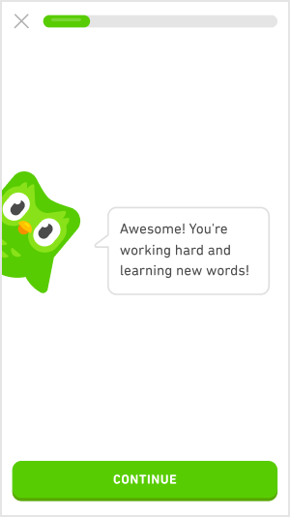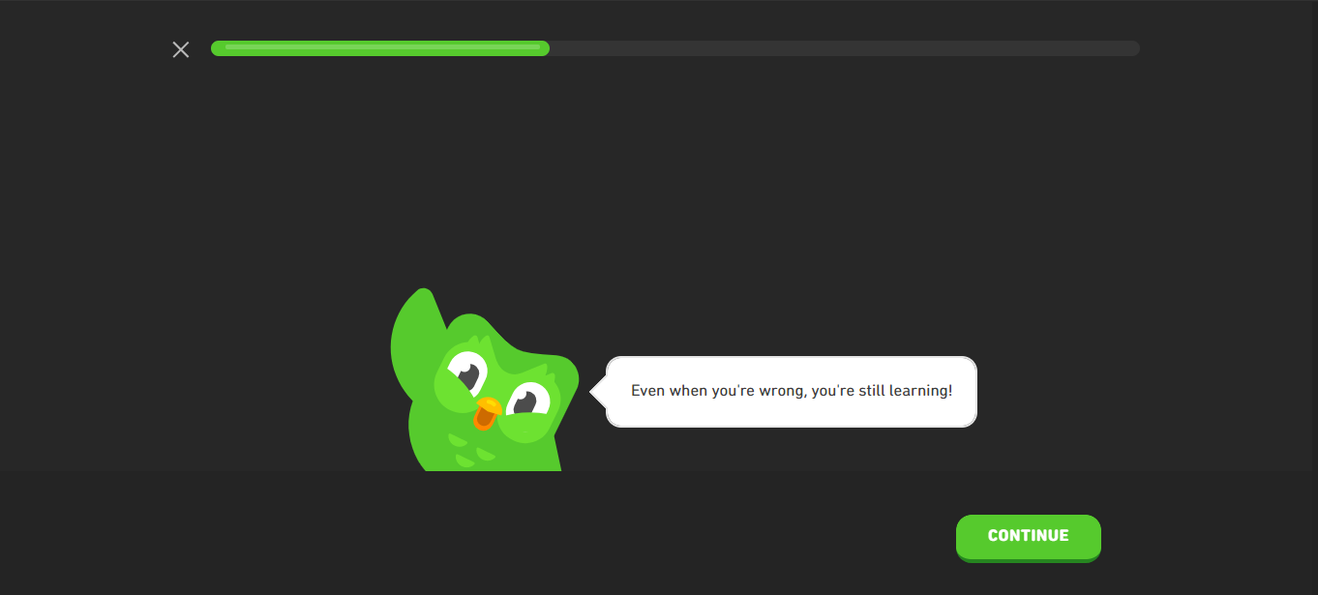

Duolingo’s feedback and encouragement works on top of SDT

We also consider another notable study done by Matsuno et al. (2021), which shows that in their flood simulation app.

Matsuno et al’s app consists of narrative scenarios and quizzes that offer a sense of autonomy. The user is provided with the freedom of agency in a safe simulated environment which helps them to make choices and directly observe direct consequences

Compare it to reading a simple top down list of instructions, the user exhibited improved competency, suggesting that Matsuno et al’s app is a superior learning tool

According to another study done by the same Kankanamge et al., shows that leaderboards and social sharing can produce the psychological aspect relatedness in the self determination theory (SDT)

This enabled the ability to transform readiness from a solitary task into a communal, social activity ("Your neighborhood is 70% Rally-Ready").

**From SDT (Why) to Gamification (How), this theoretical-to-practical pipeline offers a strong, fact-based defense of Rally's fundamental architecture.**

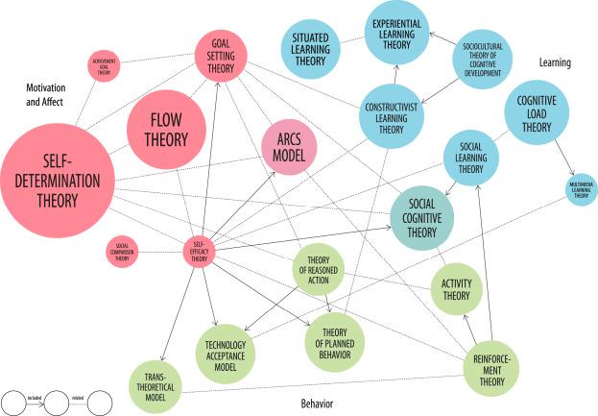

ScienceDirect 2021Revealing the theoretical basis of gamification

## 2.5. Evidence in Practice: Proven Components, Unsynthesized

This is the last part of the report which outlines the 3 different case studies to evaluate the differences, the pros, cons, success and failures of each app. Try to combine the things that works to outline what an effective Rally MVP should be

| **Case Study 1** | **Case Study 2** | **Case Study 3** |
| --- | --- | --- |
| **The Platform (FEMA & Zello)** | **The Habit-Building Mechanic (Duolingo & Fitbit)** | **The Market Failure (Met Office vs. Red Cross)** |
| The FEMA app has   * Enabled the cell phone to be a life saver during crises * Widely trusted by US citizens * Provides reliable information on shelter locations and more       Zello App | Fitbit step goal & Duolingo   * Proven to provides a good low and slow long term task * Prime examples of competence feedback loop in action * Gamified mechanics to effectively create and sustain habits long term | Met office App   * Lacks some of the functionality as compared to the other apps here   Red Cross App   * Features essential offline capable guides * Extensive knowledge base for survival * No localized real time data integration |

### 

| **Features** | Gamification? | Real Time? | Offline Capable? |
| --- | --- | --- | --- |
| Fema | No | Yes | Partial (only checklists) |
| Zello | No | Yes (Live Audio) | No |
| Met Office | No | Yes | No |
| Red Cross | Partial (Quizzes/badges) | Yes | Yes |
| Rally (proposed) | **Yes** | **Yes** | **Yes** |

### 

### 2.5.1 Summarized Comparison2.6 SWOT Analysis

A study to identify Rally’s internal strengths, weakness, as well as its external opportunities and threats

| **Strengths**  Rally’s model is unique hybridized model of the three proven pillars of human computer interaction and interaction design   * Gamification * Real time alerts * Offline centric design   Rally’s foundation design is also based around strong theoretical rigor where the SDT (self determination theory) is applied from a top down approach | **Weaknesses**  It might be dependent on external APIs in its response hub and this means that real time updates and alerts may not be robust as the Gamification and preparedness section |
| --- | --- |
| **Opportunities**  The market gap analysis shows a clear cut market void  Existings apps are either:   1. Data first (alerts) 2. Static guides   This provides a clear opportunity for Rally to provide a synergized hybrid solution  Climate change increasing frequencies of disasters due to CO2 emission also provides with a rising demand for disaster preparation | **Threats**  Existing apps such as Met Office or FEMA could easily integrate my other features into their app reducing Rally’s unique value proposition |

## 2.7 Critique of this literature review

**Strength of my argument in this literature review**

The strongest point of my argument in this literature review is presented 2.2, with the rejection of the information deficit model. This after further analysis and research, replaced the informational deficit model with the “Motivational Deficit” model

My argument shifts that the solution of this being a “we need better code” problem, to be a “we need better psychology & design”: a human computer interaction (HCI) problem  
  
My literature reviews justify the why, of needed Rally, instead of just a better pamphlet or website

My information “Silo” argument categorizes existing solutions into classes such as “Data-first” or “Content-first”  
I prove through a visual matrix where the intersection exists between the Data first and content first functionality as the gap that Rally can bridge

And my theoretical application of bridging Self Determination Theory (SDT) to gamification mechanics further shows that Rally is not just any gimmick, but a solution derived from academic rigor

Gamification elements like progress bars, badges, fun colors, fonts and animations aren’t just for fun. It provides motivation and psychological satisfaction to the "Competence" pillar of our psychological framework

**Critical Weaknesses & Blind spots (The “Gaps”)**

I haven’t fully addressed the "Trivialization" Paradox presented when Gamification exists. I argued that gamification solves the engagement problem, but i have not fully mitigated the risk of gamification trivializing life or death context

I have not fully tested if badges, points, fun and friendly colors would make a crisis feel less serious, and its extent thereof.

I like to use Duolingo as examples of success stories of engagement but fail to mention the problem that these apps face, that they too often suffer from the “Novelty Effect”, that users are motivated for up to 2 weeks, which they often then get bored when badges stop feeling special

Since this literature review showed that disaster preparation is a “forever” task, my literature review assumes that the gamification works indefinitely, and for sure Rally would suffer the “Novelty fatigue” effect as duolingo as fitbit

Another area worth critiquing is that my review implies gamification works for everyone without any demographical considerations. My problem statement includes elders but i did not study now gamification will impact a 70 year old, or if it will backfire

There is no literature to analyze the gamification efficacy for different ages, races, ethnicity or people with different cultural background

It also doesn't consider the efficacy of gamification for people with mobility, mental or visual impairment, maybe gamification may be too overly stimulating for a person on the spectrum, or if the animation or how different transition elements might affect epilepsy. These are all areas of consideration not studied on the literature review

**Final Acknowledgement & consolidation**

I acknowledge that gamification is the “hook” for engagement within the first 72 hours which is the most critical.

## 2.8 Conclusion

The Rally Synthesis

This literature review has clearly established that the core idea of the preparedness gap that is pervasive throughout communities is not a result of information scarcity, but a resultant of behavioral and psychological challenges caused by badly presented data, or poorly formatted information

While traditional methods based on the information deficit have failed to engage users, SDT is a robust and theoretical framework for addressing this gap

| **Document Meta data** | |
| --- | --- |
| **Word count**  **1885/2500**  Excluding image citations |  |

# 3. Design Document

### **3.1 Project Overview**

The document details the design and implementation for “Rally” a solution to solve the preparedness gap through the use of a high fidelity MVP (minimum viable product) application replacing the current on the market passive, and generic information “digital guidebooks”

The purpose of Rally is to not only provide passive information but actively engage users for disaster preparation

The core problem identified in the problem statement shows that

1. Low engagement in preparedness
2. Information fragmenting during a crisis

Is the main obstacles to disaster preparation

#### **3.1.1 The 3 Core Philosophical Component**

The philosophical component of Rally can be separated into 3 distinct component



**Prepare module**

* User centric module
* Gamified design
* Uses points, progress bars, quizzes to incentivize action

**Alert module**

* Solve information fragmentation through timely, location based emergency alerts
* Offline-capable database of local contracts and safety guidelines
* Ensuring app functions as a calm lifeline even if networks fail

**Resource module**

The resource module enable offline functionalities where critical information such as local emergency contacts

**Guiding principles**

As stated in the ethics audit, the ethical guardrails, especially the safety critical nature, and the privacy requirements alongside with data protection compliance are clearly outlined in the ethics audit in the document above

#### 

#### **3.1.2 Philosophical Foundation**

The philosophy behind our app, Rally is built on the understanding of the Self-determination theory (SDT), as outlined in previous parts of this document, SDT outlines human motivation which fuels competence, autonomy and relatedness

Rally where we optimize preparedness by smart Ixd (interaction design) considerations built around the idea of SDT to solve the preparedness gap

According to SDT, true motivation relies on three psychological needs: Competence, Autonomy, and Relatedness. This theory is directly applied in our design through the use of intelligent interaction design (IxD) and gamification, which endows users with a feeling of control and mastery. In this way, it effectively addresses the “preparedness gap” that has not been bridged by passive tools.

## 

### **3.2 Domain and users**

“Rally” is an app that operates in the safety-critical domain of personal disaster preparedness and emergency responsiveness.

It is not of a singular domain, it has a dynamic context but within the parameters of a dual state user experience

| **The "Prepare" State (Peacetime)** | **The "Response" State (Crisis):** |
| --- | --- |
| In the prepare state, it is in the domain of the low stress, amotivational state  This is when the user is safe, and has low engagement with the app  Main challenges includes   * overcoming the initial cognitive overload and procrastination   The domain’s goal is to motivate, educate and reward through SDT principals | In the response state, there is urgency and high stress, with the context being time critical  The user may be in potential danger and cognitive overload often occurs   | Domain  to provide unambiguous, actionable and rapid information with minimal steps | Requirements   * Reliable * Resilient to technical failure * Works offline | | --- | --- | |

### 3.3 Justification of features based on domain and users

**Persona 1: Sarah**

**The "Overwhelmed Procrastinator"**

| **Age:** | **34** |
| --- | --- |
| **Profile** | * Renter * Tech-savvy * Busy professional * Reads the news * Low level anxiety about being unprepared |
| **Problem** | Getting prepared feels like single, massive overwhelming task to her  She is unsure where to start and procrastinates tasks   * Suffers from “amotivation” * Suffers from cognitive overload |
| **Goal** | * To feel a sense of control and competence,using gamification to incentivize small manageable steps, to overcome cognitive overload |
| **Rally’s Justification** | * A gamified step by step task list to break down the monolithic chore into small, manageable tasks whilst earning badges overcomes cognitive overload and according to the SDT “builds (her) competence” |

**Persona 2: David**

**The new resident**

| **Age:** | **28** |
| --- | --- |
| **Profile** | * Just moved into town * Unfamiliar with town’s facilities, landmarks and layouts |
| **Problem** | * Doesn't know regional risks * Doesn't know any emergency shelters |
| **Goal** | * To quickly obtain localized safety and preparedness briefings |
| **Rally’s Justification** | * Quizzes serves as a non passive engagement tool * Allows for learning of specific local risks and safety procedures he is unaware of |

**Persona 3: Maria**

**The "Community Caretaker”**

| **Age:** | **45** |
| --- | --- |
| **Profile** | * Highly motivated * Bad at time management * Bad at managing preparedness for multiple people |
| **Problem** | * She needs a reliable efficient single sources of truth * Worries about network failure * Worries she was unable to coordinate her family’s plan * Information fragmentation |
| **Goal** | * To have a centralized, trustworthy and reliable place to store:   + Critical contacts   + Access to first aid info   + Know what to do when power has outage |
| **Rally’s Justification** | * Checklist to track preparedness for her entire family |

## 3.4 Structure of this project

Rally’s project structure can be broadly defined as a Local first, online second, component based and modular architecture

Rally doesn't adhere to typical traditional client server applications. Rally always ensures client first, server second. Rally must be resilient even without connectivity to the outside word, ensuring it works out of the box, mostly

**Presentation layer**

* Comprehensive and well researched UI/UX based around the ideas of Ixd (interaction design) and HCI (human computer interaction), verified and audited by GOMS and KLM (keystroke level management) and tested using Fitts Law ensuring rapid information access, optimized layouts, and gamified motivational characteristics to ensure user engagement

**Logic and data layer**

* Data storage is optional and used only for tracking progress for which they can access all preparedness step instantly regardless
* Asyncstorage saves progress locally with the option of firestore NoSQL saving the data on the cloud optionally
* RSS parsers and XML feeds from Facebook profiles and channel of official government channel ensures fresh, updated, official and verifiable information whilst utilizing infrastructure that is scalable, highly redundant and available
* Risk logic calculation done locally by calculating local topological data of the user and comparing it within their 2km radius through the usage of Google Maps API, elevation api and places api
* Using google maps SDK to show all available shelters near the user

### 3.5 Key technologies and methods

**3.5.1 Project Management**

This section analyzes and breakdown the project management methodology utilized for the development of this project’s app

This section outlines important parts and definitive phases of the iterative nature of building Rally’s MVP

* **Agile Methodology:**

I selected the Agile framework, because unlike a waterfall methodology, which poses disadvantages such as a rigid and sequential model, agile the is flexible, and have continuous improvement making it an optimal choice for a project

Agile methodology is also suitable to be used for IxD analysis and for Wireframe, test, iteration and study

If my tests shows flaws, mistakes or bugs, the Agile framework’s cyclical and iterative nature allows me to adapt and reprioritize task immediately, instead of waiting for a new project phase

* **“Flavor” of Agile: Scrumban:**

I used Scrumban, a hybrid between Scrum and the flexibility of Kanban. as it is suited for an academic-led research project

| **Scrum** | **Kanban** |
| --- | --- |
| * allows me to adopt the use of Epics, and duration fixed sprints | * Good visual workflow * pull system * continuous flows can provide flexibility to manage research heavy and unpredictable tasks for my design project * Good for my GOMS analysis where i find UI inefficiencies * If i were to find these inefficiencies, i can easily add new tasks to the board and have it prioritized instantly without the need to disrupt my rigid sprint |

**Agile Methodology Management Tool: JIRA by Atlassian**

JIRA is a project management software for my Scrumban methodology, JIRA provides me with a digital, transparent and auditable "single source of truth” for all my workflows. With advanced functionality like JQL (JIRA Query Language) to Gantt charts to track progress, to Kanban boards to visualize backlogs.

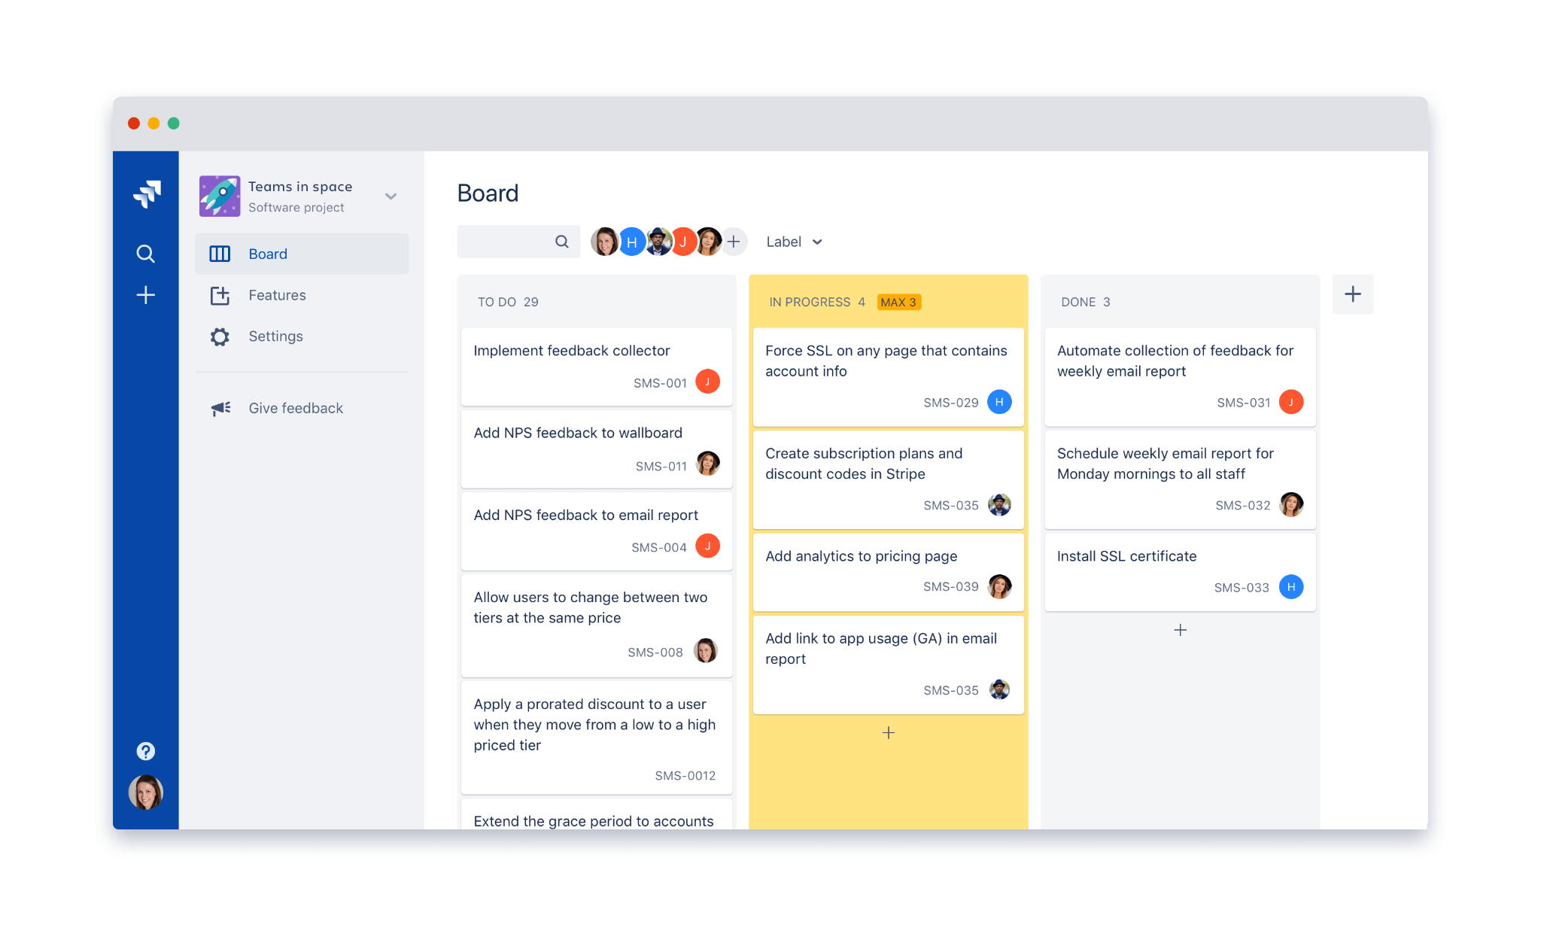

JIRA Kanban board (source: Atlassian)

**3.5.2 Ethical Testing and analysis of Ixd (Interaction design) and HCI (Human computer interaction)**

To ensure that the Response Module’s UI elements and design is effective during a crisis. I used the concept of GOMS (Goals, Operators, Methods, selection rules), combining it with KLM (keystroke-level model)

### 

### 3.6.1 Key technology, framework and services

| **Aspect** | **Technical Aspect** | **Cost** |
| --- | --- | --- |
| **Frontend UI** | ReactJs | Free |
| **UI Libraries** | **UI components can include**   * Material UI (MUI)     **Tailwind-based Libraries**   * shadc/n | Free  Optional Paid |
| **Github** | Repository | Free  Optional paid |
| **Mobile Platform** | React Native with Metro Bundler | Free  Optional paid |
| **DDoS security**  **CDN (content delivery network)** | Cloudflare DDoS protection via DNS side  Vercel / GCP DDos protection via server / serverless side | Free for GCP and Vercel  Optional paid add-ons |
| **Database** | Firestore by Google Cloud, Object based storage | Free - sparkplan,  Optional paid |
| **Axios / AJAX** | Offer API routing services | Free |
| **Kubernetes (K8)** | K8 Container orchestration using GKE (Google Kubernetes Engine) | Free  Optional paid |
| **Docker** | Containerization using docker’s YAML files | Free  Optional paid |
| **Jest** | Unit testing | Free |
| **Vercel / GCP OAuth, reCaptcha engine** | For OAuth 2.0  reCaptcha to prevent spam for account creation | Vercel free  Optional Paid add-ons |
| **Google Maps API - Google cloud platforms** | To enable maps SDK, show topological data for elevation map, nearest facilities, and more | Paid - metered |
| **Project Management** | JIRA for agile project management, managing stories, manage tickets, issues and more | Free for 1 project  Optional paid add ons |

### 3.6.2 Key technology, framework and services



**3.6.2 Conclusion:**Technical cost are zero to none, making project man and labour hours the financial bottleneck

### **3.7 Work Plan (Gantt chart)**

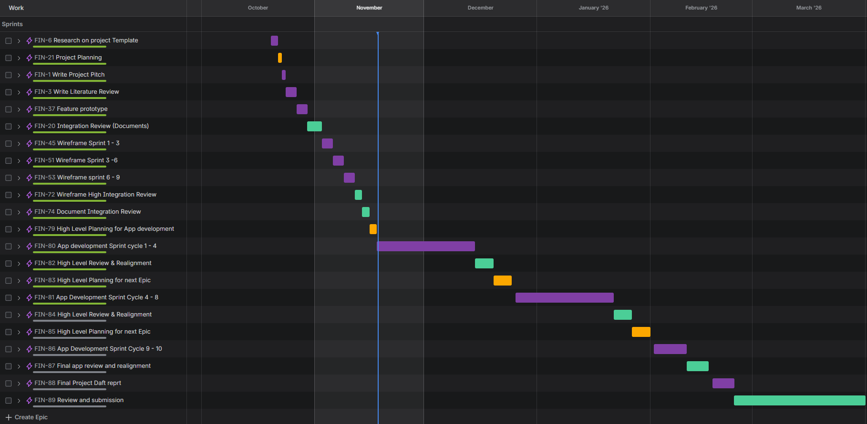



To be able to handle the complexity of this project, i developed a sprint within a nested sprint architecture within the parameters of scrumban ensuring that even high level milestones also experience similar plan - develop - test review cycles as seen from the Gantt chart, with purple being development / writing report, orange indicating Planning and green representing review

|  | An epic consists of multiple sprint cycles  From 4 cycles per Epic to 2 cycles per Epic |
| --- | --- |

|  | And within each sprint is a clear  Plan → Develop → test → review typical scrum  This kanban board exhibits our “scrumban” approach |
| --- | --- |

### 

### 

### 

### 

### **3.8 Technical Architecture**

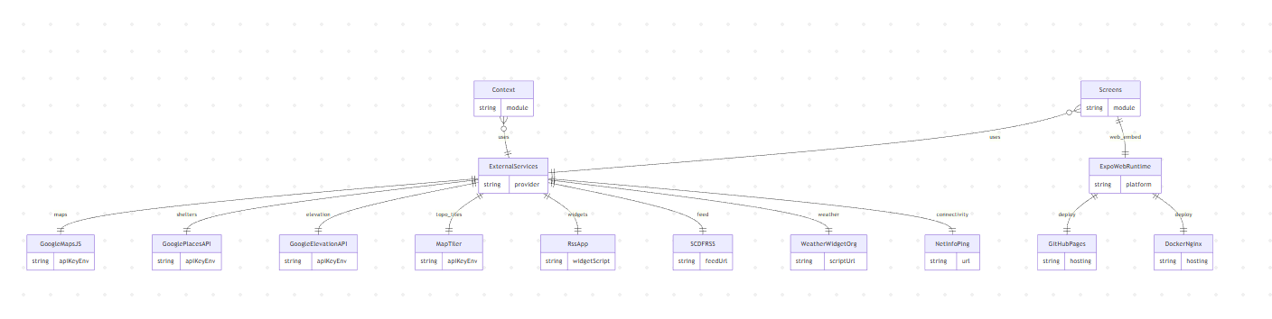

The architecture of Rally

Designed around offline-first architecture for high resilience especially in scenario where safety is critical

AsyncStorage and Local JSON schemas enables the offline first mandate, ensuring no latency during and failure

Public RSS feeds directly from reliable CDNs while the whole project is Dockerized within a Nginx container, deployed via Github Action’s CI/CD pipeline automating web exports for artifact deployment

**High Level E/R Diagram**

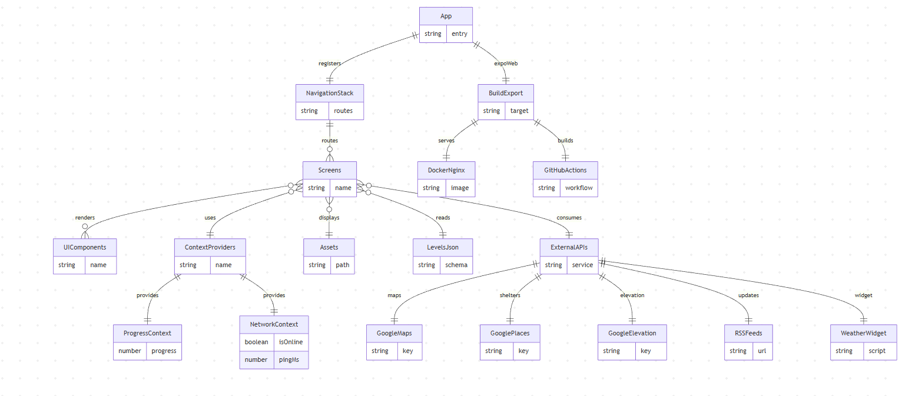**CI/CD technical pipeline**

Github actions CI/CD pipeline enabling Jest builds to be automated via Docker containerization. ensuring every deployment is production ready adhering the Safety-Critical mandate

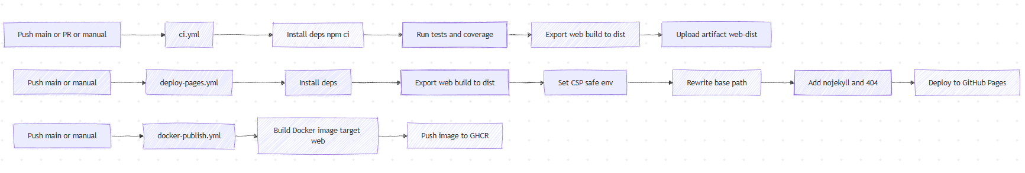

**Technical Architecture of the Dashboard, how everything fits together**

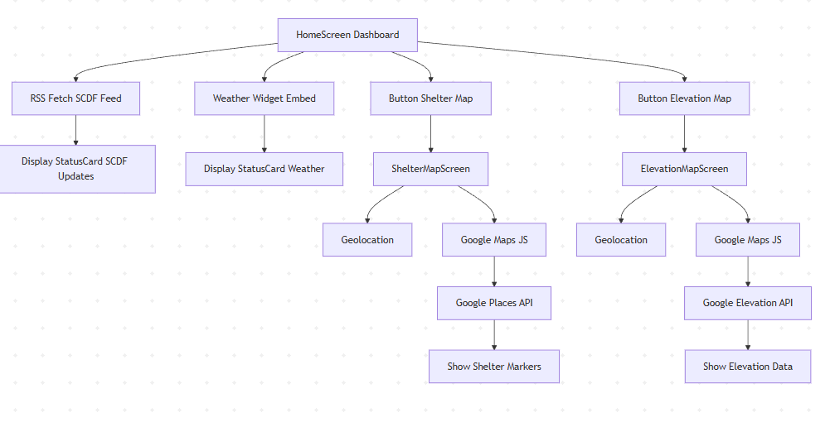

**Refer to APPENDIX: QA testing for QA test methodology**

**Refer to APPENDIX: ER Diagrams to see all the ER Diagrams**

**Refer to APPENDIX: Levels to view views data (JSON)**

**Refer to APPENDIX: Content Security Policy on Rally’s XSS cyber defense strategy**

**Refer to APPENDIX: Licensing to view Rally’s TOS**

### **3.8.1 Architectural Justification: The CAP Theorem**

CAP theorem refers to a law that a distributed system (in this case availability zones and servers for GCP) can only simultaneously provide two of three guarantees: Consistency, availability and partition tolerance

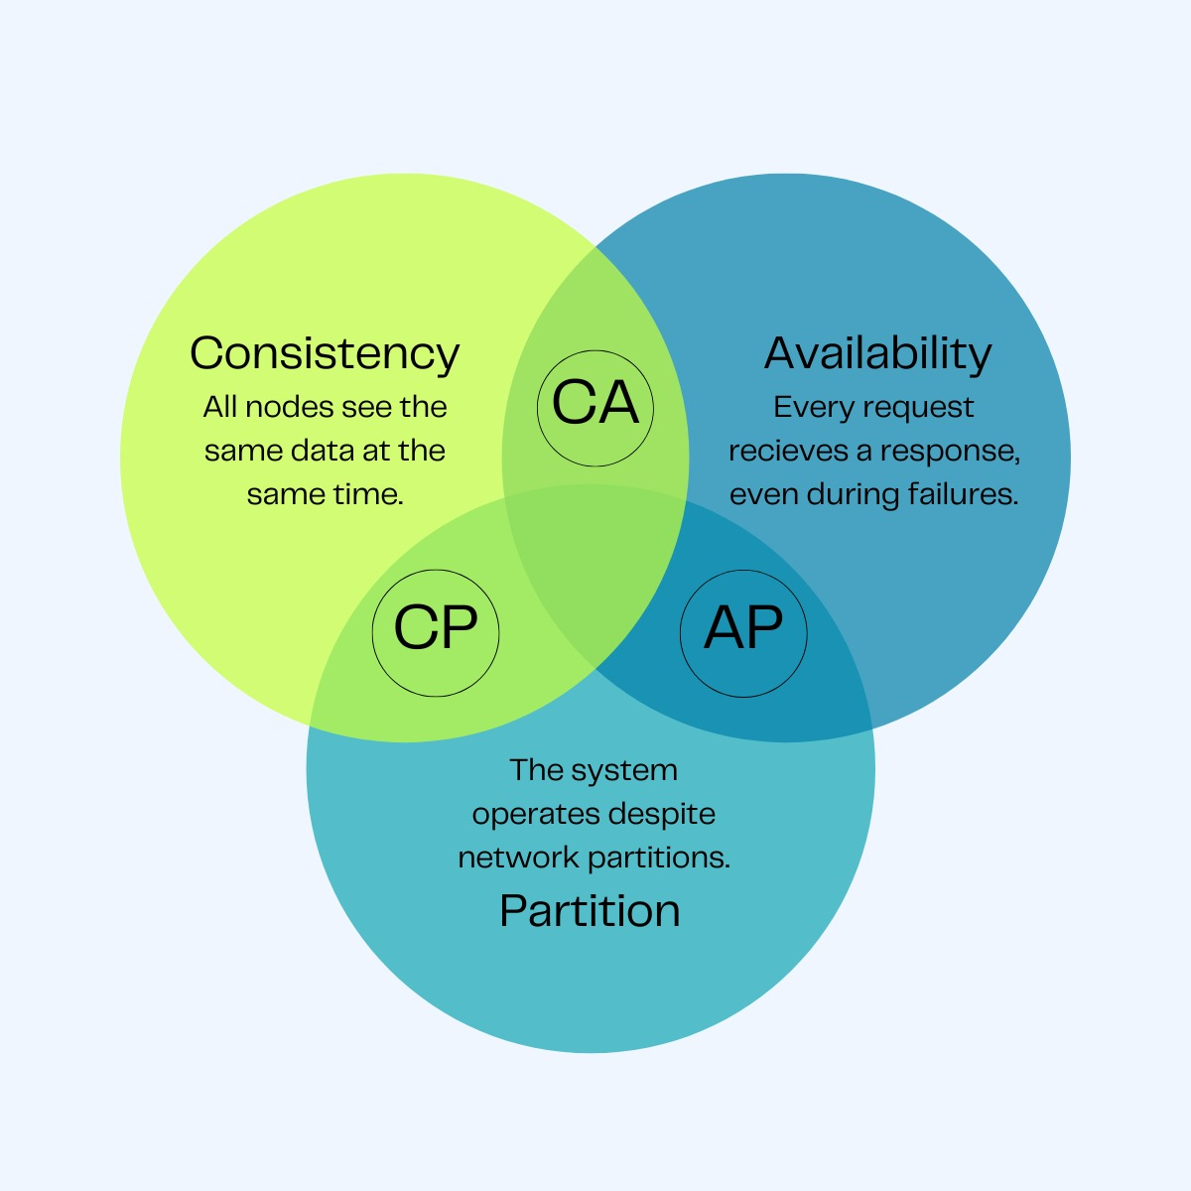

For RALLY Partition Tolerances will most likely happen due to disasters and consistency, though it is expected as Rally has an offline first design

**Rally’s justification**

In a high stakes life /death scenario, a user to seeing a stale, 1 hour old shelter geographic data is acceptable but unavailability due to connection is unacceptable justifying my Offline-first mandate

### **3.8.2 Algorithmic analysis**

**3.8.2.1 Geospatial algorithm**

To perform a High Ground filter or locate predetermined shelters using google maps SDK within a 2km^2 radius through Haversine Formula to determine the circle distance between 2 points on a sphere (earth is spherical)

Distance d is calculated as:

$a = sin^{2}(\frac{Δϕ}{2}) + cosϕ_{1}* cosϕ_{2} * sin^{2}(\frac{Δλ}{2})$

$c = 2 * atan(\sqrt{a}, \sqrt{1-a})$

$d = R*c$

**3.8.2.2 Time Complexity Analysis**

By identifying every node in maps SDK, the algorithm becomes O(N), A bounding box and prefilter forces searches to be localized to within the user before the expensive algorithm is implemented efficiently keeping it O(1) relative to the total database size in practical usage



**3.8.2.3 Data persistence schema**

Using NoSQL object document storage: Firebase and AsyncStorage aligns with the offline first mandate through rapid serialization of JSON objects without SQL parsing





| **Document Meta data** | |
| --- | --- |
| **Word count**  **1989/2000** |  |

# 4. Feature prototype

### **4.1 Initial High Fidelity Wireframe**

skipped implementing the low and medium fidelity wireframe and straight to a high fidelity wireframe due to the advent of modern UI tooling like Figma. Allow for rapid UI builds and iteration negating the traditionally associated handdrawn low fidelity wireframing

Overview of the entire UI and its corresponding screens

#### 

**Total Satisfaction review**

This total satisfaction review consists of 20 participants who rate each User experience and feedback on each of their aesthetics, readability, lack of cognitive overload and ease of use

| **Aesthetics** | **Readability** | **Lack of cognitive overload** | **Ease of use** |
| --- | --- | --- | --- |
| **5** | **5** | **4** | **4** |

|  | If there is no signal, and offline centric features kick in, an alert will appear if user is on the real time updates screen  The alerts don't appear on other screen to reduce cognitive overload |
| --- | --- |



| **Aesthetics** | **Readability** | **Lack of cognitive overload** | **Ease of use** |
| --- | --- | --- | --- |
| **5** | **5** | **4** | **4** |

The initial warning screen to indicate that this is not a replacement for emergency services to avoid trivialization, followed by the select language screen: We should not assume a person’s default operating language

| Gamification features:  Inspired by duolingo’s user interface, this map is a fun way to show preparedness progression, motivating users to finish all their preparedness tasks |  |
| --- | --- |

| **Aesthetics** | **Readability** | **Lack of cognitive overload** | **Ease of use** |
| --- | --- | --- | --- |
| **5** | **5** | **5** | **5** |

| **Quizzes: Most Critical Checklists**  The tasks where it is the most important will have pictogram and graphics to engage the user, thus inducing motivation |  |
| --- | --- |

| **Aesthetics** | **Readability** | **Lack of cognitive overload** | **Ease of use** |
| --- | --- | --- | --- |
| **5** | **5** | **5** | **4** |

| **Quizzes: Medium priority Tasks**  Tasks in medium priority comes after tasks in high priority, this means that i would need to remove the pictogram to reduce cognitive overload now that motivation is less of a factor |  |
| --- | --- |

| **Aesthetics** | **Readability** | **Lack of cognitive overload** | **Ease of use** |
| --- | --- | --- | --- |
| **5** | **5** | **5** | **5** |

| **Quizzes: Low priority Tasks**  Tasks in low priority come after tasks in medium priority, it is more of an exhaustive list. Motivation is well underway here and cognitive overload will be minimal as the tasks is truncated |  |
| --- | --- |

| **Aesthetics** | **Readability** | **Lack of cognitive overload** | **Ease of use** |
| --- | --- | --- | --- |
| **5** | **5** | **5** | **5** |

|  |
| --- |
| On the home screen dashboard, if the user clicks on the real time updates, it will reveal a log of updates while hiding the other buttons This is to reduce cognitive overload  The current status element remains persistent even with the transitions as it is high priority information |

| **Aesthetics** | **Readability** | **Lack of cognitive overload** | **Ease of use** |
| --- | --- | --- | --- |
| **5** | **5** | **3** | **5** |



| **Aesthetics** | **Readability** | **Lack of cognitive overload** | **Ease of use** |
| --- | --- | --- | --- |
| **5** | **5** | **4** | **4** |



The user has the option to select between elevation map and shelter map

Elevation map is especially useful for floods,tsunamis, while shelter maps is useful for disasters like earthquakes, storms

| **Aesthetics** | **Readability** | **Lack of cognitive overload** | **Ease of use** |
| --- | --- | --- | --- |
| **5** | **5** | **4** | **4** |

### 

### 

### **4.4 Ixd Audit**

#### 4.4.1 KLM (Keystroke Level Management) Audit

KLMS takes a chance at predicting the average time for a user to complete a task, this KLM analysis takes the average time it takes for the user to click on certain buttons and perform an operation.

This study took place over 1 week, with some 10 different participants

|  | | **Phone** | Iphone | Samsung | | --- | --- | --- | | Avg click time | 1.4s | 1.52s | |
| --- | --- | --- | --- | --- | --- | --- | --- |

|  | **Selecting options**   | **Phone** | Iphone | Samsung | | --- | --- | --- | | Avg click time | 2.3s | 2.8s |   **Clicking proceed**   | **Phone** | Iphone | Samsung | | --- | --- | --- | | Avg click time | 1.2s | 1.1s | |
| --- | --- | --- | --- | --- | --- | --- | --- | --- | --- | --- | --- | --- | --- |

|  | **Selecting options**   | **Phone** | Iphone | Samsung | | --- | --- | --- | | Avg click time | 1.02s | 1.01s |   **Clicking “Ready to move on?”**   | **Phone** | Iphone | Samsung | | --- | --- | --- | | Avg click time | 1.2s | 1.1s | |
| --- | --- | --- | --- | --- | --- | --- | --- | --- | --- | --- | --- | --- | --- |

|  | **Selecting options**   | **Phone** | Iphone | Samsung | | --- | --- | --- | | Avg click time | 1.01s | 1.01s |   **Clicking “Ready to move on?”**   | **Phone** | Iphone | Samsung | | --- | --- | --- | | Avg click time | 1.2s | 1.1s | |
| --- | --- | --- | --- | --- | --- | --- | --- | --- | --- | --- | --- | --- | --- |

|  | **Selecting options**   | **Phone** | Iphone | Samsung | | --- | --- | --- | | Avg click time | 2.3s | 2.25s |   **Clicking “Ready to move on?”**   | **Phone** | Iphone | Samsung | | --- | --- | --- | | Avg click time | 1.2s | 1.2s | |
| --- | --- | --- | --- | --- | --- | --- | --- | --- | --- | --- | --- | --- | --- |

|  | **Clicking on back**   | **Phone** | Iphone | Samsung | | --- | --- | --- | | Avg click time | 1s | 0.98s | |
| --- | --- | --- | --- | --- | --- | --- | --- |

#### 

#### 

|  | **Clicking on elevation map**   | **Phone** | Iphone | Samsung | | --- | --- | --- | | Avg click time | 1.2s | 2s |   **Clicking on shelters map**   | **Phone** | Iphone | Samsung | | --- | --- | --- | | Avg click time | 1.25s | 1.23s |   **Clicking on Preparation**   | **Phone** | Iphone | Samsung | | --- | --- | --- | | Avg click time | 1.s | 1.2s | |
| --- | --- | --- | --- | --- | --- | --- | --- | --- | --- | --- | --- | --- | --- | --- | --- | --- | --- | --- | --- |

### 

### 

### 

### 

### 

### 

### 

### 

### 

### **4.5 Mockups**

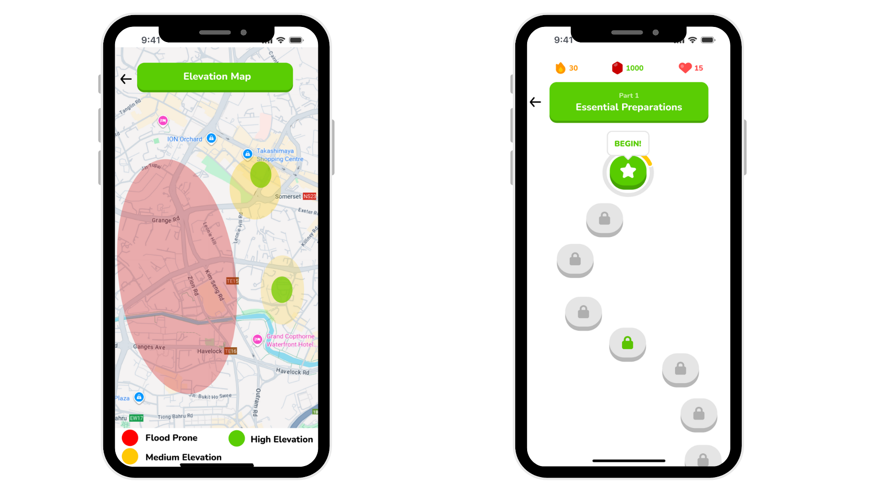

### 

### 

### 

### 

### **4.7 Initial Minimum Viable product (Prototype)**

| **Prototype** | **High Fidelity Wireframe** |
| --- | --- |
|  |  |
| Changes and rationale  Remove the high alert risk, remove the incoming section because the Singapore government doesn’t provide such api services to the public, nor they have such api data layers  The government update now features RSS feed directly to the Civil defence force’s and official government’s facebook updates which they use as a public announcement platform.  The government dont publish any data as a api data layer  Instead i implemented a Weather iframe widget from a trusted source  *Design iterations did not impact the average time-to-click on the high-fidelity wireframes* | |

| **Aesthetics** | **Readability** | **Lack of cognitive overload** | **Ease of use** |
| --- | --- | --- | --- |
| **3** | **5** | **4** | **4** |

| **Prototype** | **High Fidelity Wireframe** |
| --- | --- |
|  |  |
| Changes and rationale  Geospatial evaluation confirmed that Singapore's topography is predominantly flat (max elevation <164m), necessitating a logic adjustment from 'Absolute High Ground' to 'Relative High Ground' within a 2km user radius.  *Design iterations did not impact the average time-to-click on the high-fidelity wireframes* | |

**Survey for feature prototype**

| **Aesthetics** | **Readability** | **Lack of cognitive overload** | **Ease of use** |
| --- | --- | --- | --- |
| **5** | **5** | **4** | **4** |

| **Prototype** | **High Fidelity Wireframe** |
| --- | --- |
|  |  |
| Changes and rationale  Analysis indicated that during national disasters, official government portals often experience high latency due to traffic spikes. Consequently, the architecture was pivoted to utilize Facebook's CDN infrastructure as a high-availability channel for official announcements.  A facebook post from [Gov.sg](http://gov.sg) is a main page for matters relating to Singapore, so its a central bulletin for security crises like terrorism, transport disruption or extreme weather updates  Additionally, a facebook post from [Gov.sg](http://gov.sg) or SCDF (civil defence force) is qualitative in context often with pictures and description, which allows users to understand immediately. This bridges the gap in the Gulf of evaluation in our IxD philosophy as actionable instructions are distributed instead of raw api json objects from official APIs that are hard to get | |

**Survey for feature prototype**

| **Aesthetics** | **Readability** | **Lack of cognitive overload** | **Ease of use** |
| --- | --- | --- | --- |
| **3** | **5** | **4** | **4** |

| **Prototype** | **High Fidelity Wireframe** |
| --- | --- |
|  |  |
| Changes and rationale  The high fidelity wireframe looks too much like duolingo’s which may trigger plagiarism or infringement of rights. Thus significant UI design changes was necessary to comply with intellectual property laws | |

**Survey for feature prototype**

| **Aesthetics** | **Readability** | **Lack of cognitive overload** | **Ease of use** |
| --- | --- | --- | --- |
| **3** | **5** | **4** | **4** |

| **Prototype** | **High Fidelity Wireframe** |
| --- | --- |
|  |  |
| Changes and rationale  The high fidelity wireframe looks too much like duolingo’s which may trigger plagiarism or infringement of rights. Thus significant UI design changes was necessary to comply with intellectual property laws | |

**Survey for feature prototype**

| **Aesthetics** | **Readability** | **Lack of cognitive overload** | **Ease of use** |
| --- | --- | --- | --- |
| **3** | **5** | **4** | **4** |

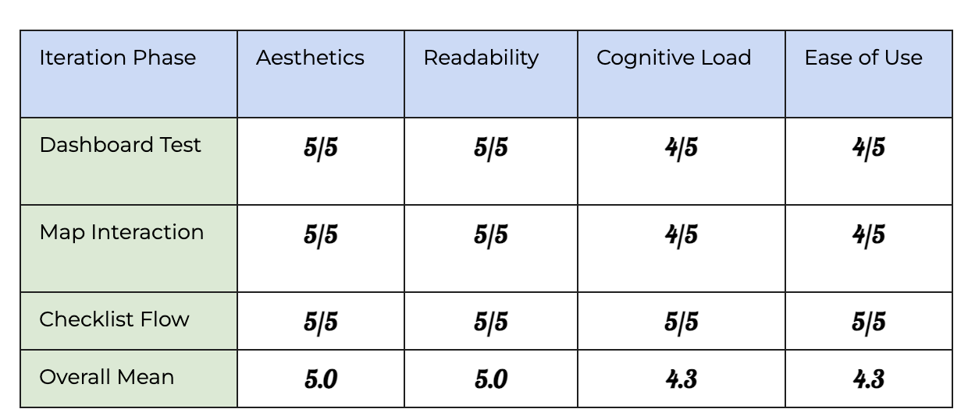

### **4.8 Inclusivity Audit**

#### **4.8.1 Accessibility & WCAG 2.1**

Given the “Safety-Critical” nature of Rally inclusivity is not optional, it is critical. I audited Rally against Web Content Accessibility Guidelines (WCAG) 2.1 Level AA standards

#### **4.8.2 Visual Impairments**

High contrast color scheme #2DB200 with #FFFFFF, this specific color pairing between neutral font colors with #2DB200 coloring ensure that there will be no ambiguity in high stress scenario even for users with low vision or color blindness

#### **4.8.2 Motor Impairments Impairments**

All **critical** interactive elements like buttons or toggles must adhere to minimum touch target of 48x48dp and within reachability thresholding reducing ‘fat finger’ errors during crisis and nerve wracking events and ensuring that all elements are reachable for the average human adult hand

#### **4.8.3 Screen Readers**

All images and icons utilize semantic aria-label and accessibilityLabel props to ensure full compatibility with assistive technologies like ios’s VoiceOver or Android's TalkBac

| **Document Meta data** | |
| --- | --- |
| **Word count**  **1298/2000** |  |

# 5. Evaluation

Final app hosted at github pages on:

| https://yanguangchen.github.io/FinalProject2025/ |
| --- |

Repository Link

| https://github.com/Yanguangchen/FinalProject2025 |
| --- |

Through manual Github actions CI/CD deployment, note that online features are disabled in this hosting due to conflicting CSP policy violation when introducing RSS feeds

**Swift Cycle 1**

Evaluation Phase

**Date:**

**Participants:5**

**Profile:** University Peers, Tech-Savvy

| Evaluation Question | | |
| --- | --- | --- |
| The app's navigation structure (Home/Map/Checklist) is intuitive. | | |
| | Agree | Partially Agree | Neutral | Partially Disagree | Disagree | | --- | --- | --- | --- | --- | | 5 | - | - | - | - | | | |

| Evaluation Question | | |
| --- | --- | --- |
| Information is easier to digest here than in a standard PDF guide. | | |
| | Agree | Partially Agree | Neutral | Partially Disagree | Disagree | | --- | --- | --- | --- | --- | | 4 | 1 | - | - | - | | | |

| Evaluation Question | | |
| --- | --- | --- |
| I understand what the "Emergency Mode" button is for. | | |
| | Agree | Partially Agree | Neutral | Partially Disagree | Disagree | | --- | --- | --- | --- | --- | | 3 | 2 | - | - | - | | | |

| Evaluation Question | | |
| --- | --- | --- |
| The initial signup/onboarding process felt quick and privacy-safe | | |
| | Agree | Partially Agree | Neutral | Partially Disagree | Disagree | | --- | --- | --- | --- | --- | | 4 | 1 | - | - | - | | | |

**Qualitative Feedback**

* *“I felt that the concept was nice, I guess”*
* *“Sometimes i mistook the red button for log - out button”*
* *“The emergency mode kinda looks like a physical switch?”*

**Swift Cycle 2**

Evaluation Phase

**Date:**

**Participants: 5**

**Profile:** Mixed demographic, including 2 non-technical users

**Focus:** Testing the "Motivation" hypothesis (SDT) and Map API integration

| Evaluation Question | | |
| --- | --- | --- |
| Earning points/badges makes the preparation tasks feel less boring. | | |
| | Agree | Partially Agree | Neutral | Partially Disagree | Disagree | | --- | --- | --- | --- | --- | | 1 | 3 | 1 | - | - | | | |

| Evaluation Question | | |
| --- | --- | --- |
| The elevation map loaded quickly and showed my location accurately. | | |
| | Agree | Partially Agree | Neutral | Partially Disagree | Disagree | | --- | --- | --- | --- | --- | | 3 | 1 | 1 | - | - | | | |

| Evaluation Question | | |
| --- | --- | --- |
| I understand what the "Emergency Mode" button is for. | | |
| | Agree | Partially Agree | Neutral | Partially Disagree | Disagree | | --- | --- | --- | --- | --- | | 1 | 1 | 2 | 1 | - | | | |

| Evaluation Question | | |
| --- | --- | --- |
| The initial signup/onboarding process felt quick and privacy-safe | | |
| | Agree | Partially Agree | Neutral | Partially Disagree | Disagree | | --- | --- | --- | --- | --- | | 2 | 2 | 1 | - | - | | | |

**Qualitative Feedback**

"The checklists are very engaging, I enjoyed completing them."

"The map works, but it is a little choppy and laggylags a bit when I scroll to a new area. Also, some elements of the map diagram flickered."

Action Taken: By limiting the elevation fetch rate (debouncing), the MapView rendering was optimized. "Safety Tips" has a larger font size in order to comply with WCAG 2.1 accessibility guidelines

**Swift Cycle 3**

Evaluation Phase

**Date:**

**Participants: 5**

**Profile:** 5 Final target audience validation

**Focus:** Safety Critical" mandates with Offline mode and Resource Hub

| Evaluation Question | | |
| --- | --- | --- |
| I could easily find the nearest shelter even when 'Airplane Mode' was on. | | |
| | Agree | Partially Agree | Neutral | Partially Disagree | Disagree | | --- | --- | --- | --- | --- | | 5 | - | - | - | - | | | |

| Evaluation Question | | |
| --- | --- | --- |
| The switch between "Prepare Mode" and "Emergency Mode" is clear. | | |
| | Agree | Partially Agree | Neutral | Partially Disagree | Disagree | | --- | --- | --- | --- | --- | | 5 | - | - | - | - | | | |

| Evaluation Question | | |
| --- | --- | --- |
| The instructions in the Offline Resource Hub are easy to follow in a panic. | | |
| | Agree | Partially Agree | Neutral | Partially Disagree | Disagree | | --- | --- | --- | --- | --- | | 4 | 1 | - | - | - | | | |

| Evaluation Question | | | |
| --- | --- | --- | --- |
| I would trust this app to guide me during a real flood. | | | |
| | Agree | Partially Agree | Neutral | Partially Disagree | Disagree | | --- | --- | --- | --- | --- | | 3 | 1 | 1 | - | - | | | | |

**Qualitative Feedback**

"Everything functions flawlessly, but I'm still not entirely sure if the 'News Feed' is updating instantly. Perhaps include a "Last Updated" timestamp?

**Swift Cycle 4**

Evaluation Phase

**Date: 02 March 2025**

**Participants: 4**

**Profile:** Including 1 user with mild visual impairment and 1 older adult

**Focus:** Testing "Radical Inclusion" (WCAG compliance) and final system stability

| Evaluation Question | | |
| --- | --- | --- |
| The high-contrast text in "Emergency Mode" was easy to read without glasses. | | |
| | Agree | Partially Agree | Neutral | Partially Disagree | Disagree | | --- | --- | --- | --- | --- | | 5 | - | - | - | - | | | |

| Evaluation Question | | |
| --- | --- | --- |
| The buttons are large enough to press easily, even if I was rushing/shaking. | | |
| | Agree | Partially Agree | Neutral | Partially Disagree | Disagree | | --- | --- | --- | --- | --- | | 5 | - | - | - | - | | | |

| Evaluation Question | | |
| --- | --- | --- |
| The app maintained its state (didn't crash) when switching rapidly between tabs. | | |
| | Agree | Partially Agree | Neutral | Partially Disagree | Disagree | | --- | --- | --- | --- | --- | | 4 | 1 | - | - | - | | | |

| Evaluation Question | | |
| --- | --- | --- |
| I would recommend this app to my elderly parents or neighbors. | | |
| | Agree | Partially Agree | Neutral | Partially Disagree | Disagree | | --- | --- | --- | --- | --- | | 3 | 1 | 1 | - | - | | | |

**Qualitative Feedback**

" 'Back' button in the Shelter map was a wee bit too small for my thumb."

**Word count: 630**

# 6. Conclusion

The primary objective of “Rally” was to bridge the preparedness gap, the “gap” between public awareness of impending disaster with the actual action of preparation

With the advent of my high fidelity mobile prototype, this project successfully challenges the traditional “informational deficit” model which heavily relies on passive PDFs and static websites

Rally demonstrates the “motivational deficit” model effectively addressed through SDT (self determination theory) and gamification to provide a robust framework for community disaster preparation and resilience

## 6.1 Key project findings

Through my iterative scrubman development and evaluation process from swift cycle 1 to 4, Yielded me with 3 insights

Firstly, gamification does mitigate anxiety as Kankanamge et al. (2020) predicted. Secondly offline architecture is non negotiable as seen in swift cycle 3’s evaluation

Lastly, privacy first designs like the fully persistent local user data builds trust as seen from swift cycle 1, with the elimination of login or registration lowering the barrier to entry

## 6.2 Key project limitations

* Dependency on third party RSS and the lack of access to government API, introducing an additional point of risk
* The gamification did suffer from some level of novelty effect as seen in swift cycle 2 and 3’s evaluation
* Topographical data constraints such as the “High ground” feature was rendered hard to read since there are high rise apartments around all cities

## 6.3 Final remarks

Through Rally, I have demonstrated that disaster preparation does not need to be a chore, it can be fun, motivating and engaging with the use of smart empathetic UX with rigorous software engineering and implementation through CI/CD devops, unit testing, and app development and behavioral psychology.

In an era of increasing climate volatility, Rally offers a niche solution and acts as a scalable template for turning passive anxiety into life saving, active resilient tool

**Word count: 300**

## 7. Word Count Audit

For ease of evaluating the word count of this report i have summarised the word count below

**Total Word Count Excluding Appendix: 7182 words**

**Total Word Count including APPENDIX & Citations: 9917 words**

# Appendix:

This appendix section contains supplementary information, mostly technical documents to supplement the research and report above.

# Appendix: Testing

**Test parameters**

Test initializer

Jest (jest-expo preset)

Test match

| **/__tests__/**/*.test.[jt]s?(x) |
| --- |

Setup Files

1. Forces [Platform.OS](http://paltform.os) = “web” for web focused tests
2. Provides asynchronous data fetching via whatwg-fetch function
3. Virtualizes navigator.geolocation to default Singapore Locations
4. Silences reactive native verbose console warnings and errors
5. Provides fetching to third party URLs to Maps API, RSS and iframe widgets

**CI Node**

Uses version 20 through actions/setup-node@v4

**CI install**

npm ci --no-audit --no-fund

**Coverage**

Enabling CI via

| npm run test -- --coverage |
| --- |

**Unit Tests**

My unit tests are zoned into the rendering on individual UI components, effectively targeting aspects such as rendering, props, and basic interactions such as

| ui-arrow-back.web.test.js  ui-button-long.web.test.js  ui-button-short.web.test.js  ui-connection-banner.web.test.js  ui-progress-bar.web.test.js  ui-select-long.web.test.js  ui-signal-indicator.web.test.js  ui-status-card.web.test.js |
| --- |

**Integration tests**

My integration tests are used to validate fully complete screens and provide navigation level behaviour in the web environment

| [screens-welcome.web.test.js](http://screens-welcome.web.test.js)  [screens-language-select.web.test.js](http://screens-language-select.web.test.js)  [screens-home.web.test.js](http://screens-home.web.test.js)  [screens-preparation.web.test.js](http://screens-preparation.web.test.js)  screens-map.web.test.js (Map screen: renders level nodes and navigates to levels)  [screens-shelter-map.web.test.js](http://screens-shelter-map.web.test.js)  screens-elevation-map.web.test.js (file: [ElevationMapScreen.web.test.js](http://elevationmapscreen.web.test.js))  screens-official-updates.web.test.js |
| --- |

**Test suites**

I have had the test suites organized using folder naming under the _test_/ directory

* **UI Suite** zones in on component level tests (ui -*.[web.test.js](http://web.test.js))
* **Screens suite:** screen-level / integration tests (screens-*[web.test.js](http://web.test.js), [ElevationMapScreen.web.test.js](http://elevationmapscreen.web.test.js))

**Test results**

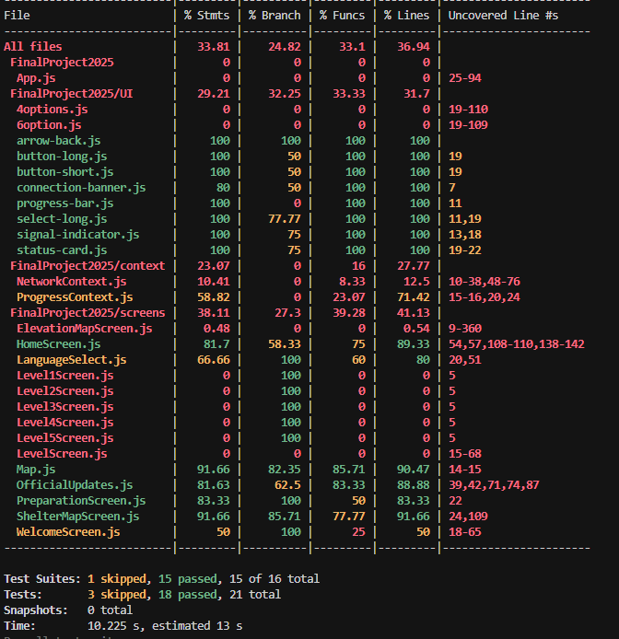

# Appendix: DevOps & CI/CD

**Docker and containerization**

My Dockerfile uses a 3 stage process in a multi-stage Dockerfile

**Stage 1:** deps:

| install Node dependencies with npm ci |
| --- |

**Stage 2:** build:

| runs the Expo web export with (npm run export:web) to generate static build in ./dist |
| --- |

**Stage 3:** web:

| copies dist/ into Nginx images and serves it from /usr/share/nginx/html |
| --- |

**Key behaviours**

* The container serves static files through Nginx
* The exported web build output directory is dist/
* The pipeline passes build time environment variables into the pipeline as Docker build arguments such as

| EXPO PUBLIC GOOGLE MAPS API KEY |
| --- |

| EXPO_PUBLIC_MAPTILER_KEY (removed later because is redundant) |
| --- |

**Nginx configuration (nginx.conf)**

**Nginx.conf** create the index for index.html, caches static assets like js or css files, images and fonts aggressively whilst creating a Single Page Element (SPA) fallback

| try_files $uri $uri/ /index.html; |
| --- |

**Local Docker Usage (docker-compoase.yml)**

**Docker-compose.yml defines 2 distinct services**

| web (production)   1. Builds the web target 2. Initializes localhost port 8000 via Nginx 3. Passes build argos for public keys | dev (for development)   1. Builds the dev target 2. Bind-mounts the repo into /app 3. runs npm run web (Expo local development server command) on localhost port 8081 |
| --- | --- |

**CI/CD pipeline**

| **Pipeline flowchart** |
| --- |
|  |

**CI/CD pipeline with Github Actions**

Workflows live in

| .github/workflows/. |
| --- |

**Part 1: Continuous Integration + static web export (ci.yml)**

Activates this continuous integration workflow

| push to main  pull_request  manual workflow_dispatch |
| --- |

What does this do

* Checkout branch
* Install dependencies
* Run tests
* Export static web build
* Verify if build output fails or passes
* Uploads the build artifact web-dist

**Part 2: Github pages deployment**

Deploy-pages.yml triggers

* Push to main
* Manual workflow_dispatch

Build job includes

* npm ci
* actions/configure-pages@v5
* CSP safe mode on pages by setting EXPO_PUBLIC_DISABLE_THIRD_PARTY_WIDGETS=1 to avoid third party widgets that may cause crashes under strict CSP environments
* Creates and verify dist/index.html
* Creates dist/.nojekyll
* Writes dist/404.html for SPA fallback
* Uploads the pages artifact from dist/

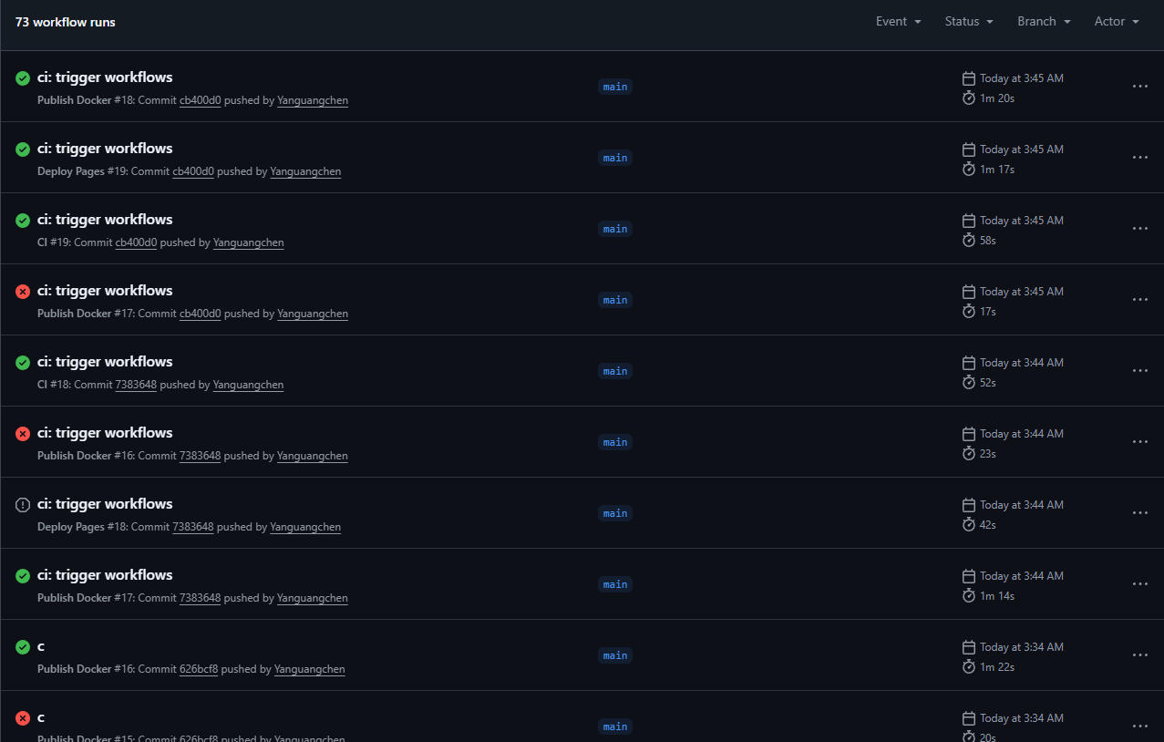

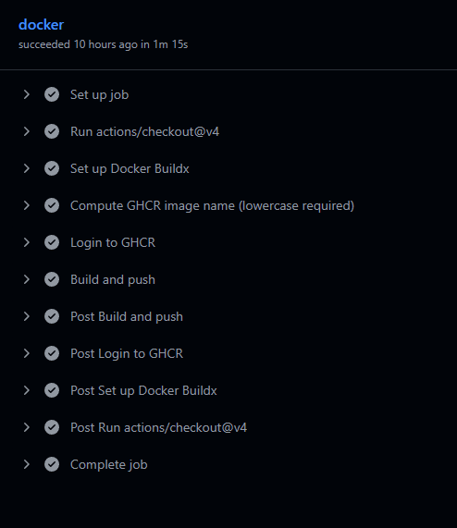

# 

# 

# Appendix: ER Diagrams and Code Architecture

[WelcomeScreen.js](http://welcomescreen.js) ER Diagram

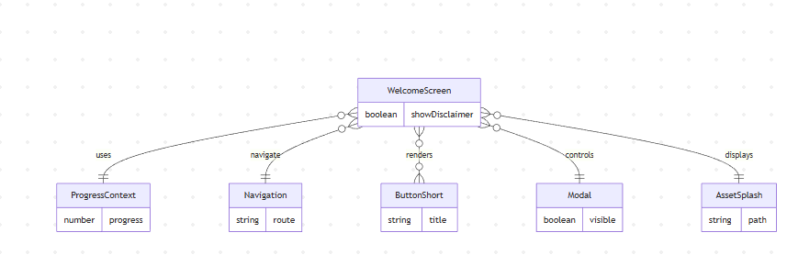

[LanguageSelect.js](http://languageselect.js) ER diagram

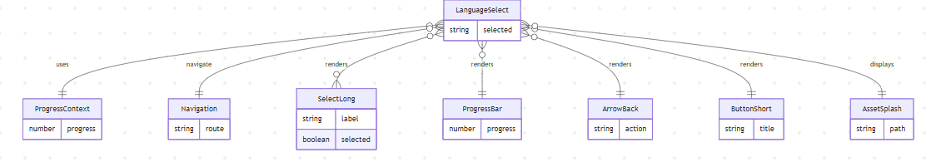

HomeScreen.js

# 

PreparationScreen.js

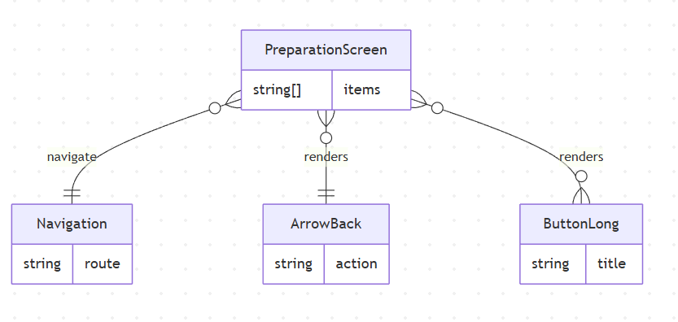

ShelterMapScreen.js

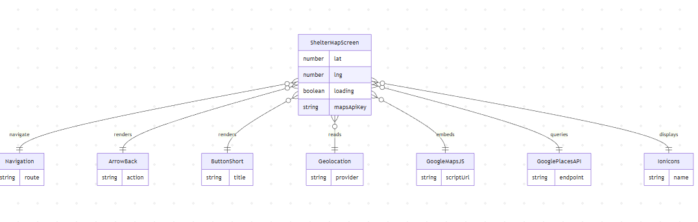

ElevationMapScreen.js

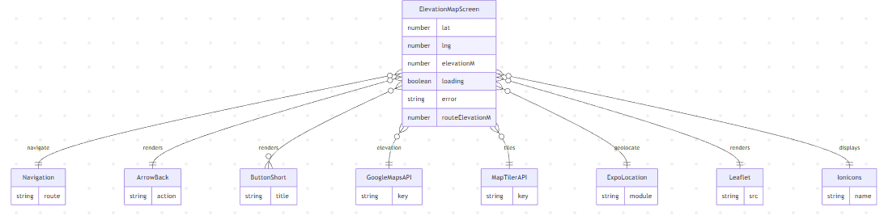

[Map.js](http://map.js)

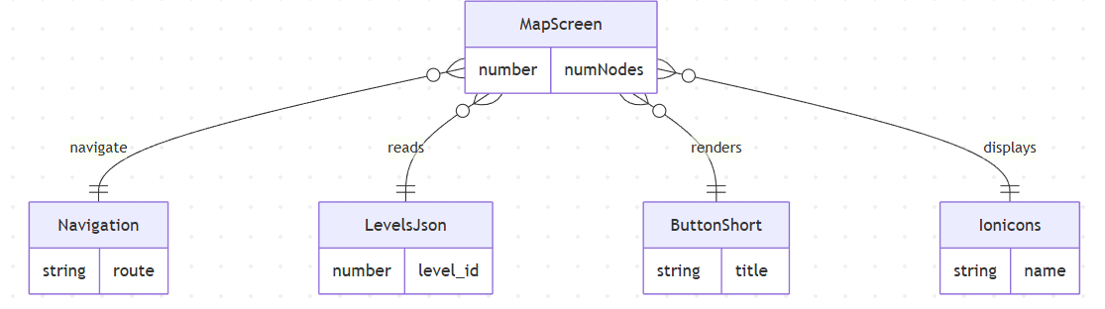

# Appendix: Glossary of Terms

| CAP (Common Alerting Protocol) | An international standard format for emergency alerting and public warning. |
| --- | --- |
| CI/CD (Continuous Integration/Continuous Deployment) | A method to frequently deliver apps to customers by introducing automation into the stages of app development |
| GOMS (Goals, Operators, Methods, Selection rules) | A specialized human-computer interaction model used to analyze the complexity of user tasks. |
| MVP (Minimum Viable Product) | A version of a product with just enough features to be usable by early customers who can then provide feedback for future product development |
| SDT (Self-Determination Theory) | A macro theory of human motivation concerned with the inherent growth tendencies and innate psychological needs (Competence, Autonomy, Relatedness) |
| WCAG (Web Content Accessibility Guidelines) | A set of recommendations for making Web content more accessible, primarily for people with disabilities. |
| JSON | Javascript object notation |
| SQL | Structured Query Language |
| RDBMS | Relational database management system |
| Time complexity | Measure of the amount of time an algorithm will complete given a input size N |

# Appendix: Levels Data

This section shows the levels and check lists of each “level” within the application in json format

| Json format, can be found in project repository too, under levels.json |
| --- |
| {  "program_title": "Rally Preparedness Progression Path",  "description": "A gamified, 5-level preparedness curriculum. Each level consists of 4 checklists: two 'Quick Wins' (4 options) and two 'Deep Dives' (6 options) to gradually increase user engagement.",  "levels": [  {  "level_id": 1,  "level_name": "The Digital Scout",  "focus": "Quick Wins & Digital Backup",  "quizzes": [  {  "quiz_id": "1.1",  "title": "Digital Vault",  "prompt": "Have you saved digital copies of these critical documents on your phone or cloud?",  "type": "multi_select_4",  "options": [  "Photo of Driver’s License / ID",  "Health Insurance Policy Number",  "Recent photo of family members",  "Proof of Address (Bill/Bank Statement)"  ]  },  {  "quiz_id": "1.2",  "title": "Personal Carry",  "prompt": "Do you have these essentials in your everyday bag or pockets?",  "type": "multi_select_4",  "options": [  "Portable Power Bank (Charged)",  "Emergency Cash (Small denominations)",  "Personal Medication (3-day supply)",  "List of Emergency Contacts (Physical copy)"  ]  },  {  "quiz_id": "1.3",  "title": "The Lifeline Check",  "prompt": "Let’s verify your communication readiness. Have you...",  "type": "multi_select_6",  "options": [  "Signed up for local SMS emergency alerts",  "Identified an 'Out-of-Area' contact person",  "Taught family members how to text vs. call",  "Programmed 'ICE' (In Case of Emergency) in phone",  "Downloaded offline maps for your area",  "Agreed on a physical family meeting spot"  ]  },  {  "quiz_id": "1.4",  "title": "Family Protocol",  "prompt": "Ensure everyone is on the same page. Have you discussed:",  "type": "multi_select_6",  "options": [  "Where to meet if separated near home",  "Where to meet if separated outside the neighborhood",  "Who picks up the children from school",  "How to use the 'I am Safe' feature on social media",  "A secret password for children to trust strangers",  "Location of the nearest police station"  ]  }  ]  },  {  "level_id": 2,  "level_name": "The Kit Builder",  "focus": "72-Hour Survival Bag",  "quizzes": [  {  "quiz_id": "2.1",  "title": "The Core Four",  "prompt": "Check off the absolute survival essentials in your bag:",  "type": "multi_select_4",  "options": [  "Water (1 liter per person or purification tablets)",  "Non-perishable food (Energy bars, canned goods)",  "Flashlight (with extra batteries)",  "First Aid Kit (Basic)"  ]  },  {  "quiz_id": "2.2",  "title": "Hygiene & Health",  "prompt": "Sanitation prevents illness during crisis. Do you have:",  "type": "multi_select_4",  "options": [  "Hand sanitizer or wet wipes",  "N95 Masks or dust masks",  "Toothbrush & Toothpaste",  "Garbage bags (for waste/waterproofing)"  ]  },  {  "quiz_id": "2.3",  "title": "The Hardware Haul",  "prompt": "Let’s finish the kit with tools and shelter items:",  "type": "multi_select_6",  "options": [  "Multi-tool or Swiss Army Knife",  "Whistle (for signaling rescue)",  "Battery-powered or Crank Radio",  "Thermal / Mylar Emergency Blanket",  "Waterproof matches or lighter",  "Manual can opener"  ]  },  {  "quiz_id": "2.4",  "title": "Advanced First Aid",  "prompt": "Upgrade your basic kit. Do you have these trauma supplies?",  "type": "multi_select_6",  "options": [  "Sterile gauze pads and tape",  "Antiseptic wipes or solution",  "Scissors and Tweezers",  "Disposable non-latex gloves",  "Burn gel or dressing",  "Instant cold packs"  ]  }  ]  },  {  "level_id": 3,  "level_name": "The Home Guardian",  "focus": "Shelter-in-Place & Home Hardening",  "quizzes": [  {  "quiz_id": "3.1",  "title": "Utility Mastery",  "prompt": "Do you know exactly where these are located and how to shut them off?",  "type": "multi_select_4",  "options": [  "Main Water Valve",  "Gas Valve (and have a wrench nearby)",  "Electrical Circuit Breaker Box",  "Main Water Drainage / Sewer Trap"  ]  },  {  "quiz_id": "3.2",  "title": "Fire & Safety",  "prompt": "Check your home safety hardware:",  "type": "multi_select_4",  "options": [  "Fire Extinguisher (ABC type, not expired)",  "Smoke Detectors (Tested this month)",  "Carbon Monoxide Detector",  "Clear exits (No furniture blocking doors)"  ]  },  {  "quiz_id": "3.3",  "title": "Flood & Storm Defense",  "prompt": "If a storm warning triggers, are you ready to secure the house?",  "type": "multi_select_6",  "options": [  "Heavy furniture secured/anchored",  "Important documents stored in waterproof container",  "Electronics elevated off the ground floor",  "Gutters and drains cleared of debris",  "Potential projectiles (patio furniture) moved indoors",  "Sandbags or door dams accessible"  ]  },  {  "quiz_id": "3.4",  "title": "Evacuation Security",  "prompt": "If you must leave immediately, is your home ready to be left?",  "type": "multi_select_6",  "options": [  "All windows and doors locked",  "Electrical appliances unplugged (except fridge)",  "Perishables removed from fridge/freezer",  "Valuables moved to upper floor or attic",  "Mail delivery paused or neighbor notified",  "Security system or cameras activated"  ]  }  ]  },  {  "level_id": 4,  "level_name": "The Community Connector",  "focus": "Vulnerable Groups & Neighborhood",  "quizzes": [  {  "quiz_id": "4.1",  "title": "The Vulnerable Check",  "prompt": "Have you accounted for specific needs in your household?",  "type": "multi_select_4",  "options": [  "Baby supplies (Formula, diapers) OR Mobility aids",  "Prescription glasses / Contact lens solution",  "Hearing aid batteries",  "Comfort item for children (Toy/Book)"  ]  },  {  "quiz_id": "4.2",  "title": "Pet Protocol",  "prompt": "Don't leave them behind. Do you have:",  "type": "multi_select_4",  "options": [  "Pet Carrier / Leash",  "3 Days of Pet Food & Water",  "Photo of you with your pet (proof of ownership)",  "Vaccination records copy"  ]  },  {  "quiz_id": "4.3",  "title": "The Network",  "prompt": "Building resilience beyond your front door:",  "type": "multi_select_6",  "options": [  "Shared spare key with a trusted neighbor",  "Identified neighbors who might need help",  "Know the route to the nearest designated shelter",  "Know the route to the nearest hospital",  "Have a physical map of the local area",  "Joined a local neighborhood watch/chat group"  ]  },  {  "quiz_id": "4.4",  "title": "External Support",  "prompt": "Do you know where to find help if local services fail?",  "type": "multi_select_6",  "options": [  "Location of nearest Police Station",  "Location of nearest Fire Station",  "Frequency of local emergency radio station",  "Contact for local Red Cross / NGO chapter",  "Location of high ground / flood evacuation point",  "Designated community relief distribution center"  ]  }  ]  },  {  "level_id": 5,  "level_name": "The Resilience Master",  "focus": "Skill Verification & Maintenance",  "quizzes": [  {  "quiz_id": "5.1",  "title": "Skill Check",  "prompt": "Items break; skills remain. Can you:",  "type": "multi_select_4",  "options": [  "Perform CPR / Basic First Aid",  "Use a Fire Extinguisher (PASS method)",  "Change a tire on your vehicle",  "Shut off utilities manually"  ]  },  {  "quiz_id": "5.2",  "title": "Vehicle Readiness",  "prompt": "If you need to evacuate by car:",  "type": "multi_select_4",  "options": [  "Gas tank always kept at least half full",  "Jumper cables in trunk",  "Spare tire and jack present",  "Car charger for phone"  ]  },  {  "quiz_id": "5.3",  "title": "The Annual Audit",  "prompt": "The final step is maintenance. Have you recently:",  "type": "multi_select_6",  "options": [  "Rotated stored water (every 6 months)",  "Checked food expiry dates and replaced items",  "Tested flashlight/radio batteries",  "Updated children's photos in digital vault",  "Reviewed insurance coverage for current value",  "Conducted a 5-minute drill with the household"  ]  },  {  "quiz_id": "5.4",  "title": "Long-Term Resilience",  "prompt": "Preparing for extended disruptions (1+ weeks):",  "type": "multi_select_6",  "options": [  "Camping stove or alternative cooking method",  "Backup power source (Solar charger / Generator)",  "Water purification system (Filter / Tablets)",  "Extra supply of critical prescription meds",  "Warm clothing / sleeping bags for all",  "Entertainment (Board games / Books) for morale"  ]  }  ]  }  ]  } |

# Appendix: Licensing

[LICENSE.md](http://license.md)

This License allows recruits and examiners/graders to run my code, look at my code and use it and is part of the open source ecosystem however, it protects me that no one can sue me if my app fails during a real disaster

| License Agreement  Copyright (c) 2025 Chen Yanguang  The MIT License (MIT)  Permission is hereby granted, free of charge, to any person obtaining a copy of this software and associated documentation files (the "Software"), to deal in the Software without restriction, including without limitation the rights to use, copy, modify, merge, publish, distribute, sublicense, and/or sell copies of the Software, and to permit persons to whom the Software is furnished to do so, subject to the following conditions:  The above copyright notice and this permission notice shall be included in all copies or substantial portions of the Software.  Academic Integrity & Plagiarism Notice:  This software was developed as part of a final year undergraduate project at University of London. While the source code is open for educational and portfolio purposes, current students are strictly prohibited from submitting this code, in whole or in part, as their own coursework. Any use of this repository for academic submissions must be properly cited in accordance with your institution's academic honesty policy.  THE SOFTWARE IS PROVIDED "AS IS", WITHOUT WARRANTY OF ANY KIND, EXPRESS OR IMPLIED, INCLUDING BUT NOT LIMITED TO THE WARRANTIES OF MERCHANTABILITY, FITNESS FOR A PARTICULAR PURPOSE AND NONINFRINGEMENT. IN NO EVENT SHALL THE AUTHORS OR COPYRIGHT HOLDERS BE LIABLE FOR ANY CLAIM, DAMAGES OR OTHER LIABILITY, WHETHER IN AN ACTION OF CONTRACT, TORT OR OTHERWISE, ARISING FROM, OUT OF OR IN CONNECTION WITH THE SOFTWARE OR THE USE OR OTHER DEALINGS IN THE SOFTWARE. |
| --- |

## 

# Appendix: Content Security Policy

This configuration file is included in my main Nginx server block within my docker container enforcing strict allowlist to mitigate cross site scripting (XSS) and data injection attacks, ensuring the application loads only from trusted sources

CSP.md

| # ----------------------------------------------------------------------  # Content Security Policy (CSP) Configuration  # ----------------------------------------------------------------------  # Architecture: React Native for Web (SPA) served via Nginx  # Objective: Restrict execution of unauthorized scripts and remote assets.  # ----------------------------------------------------------------------  add_header Content-Security-Policy "  # 1. Default Fallback  # Block everything by default unless explicitly allowed.  default-src 'self';  # 2. JavaScript Execution  # - 'self': Allow app bundle.  # - maps.googleapis.com: Required for Google Maps SDK.  # - 'unsafe-inline': Required for React Native Web's hydration process.  script-src 'self'  'unsafe-inline'  https://maps.googleapis.com  https://maps.gstatic.com;  # 3. Data Connectivity (XHR/Fetch)  # - maps.googleapis.com: For Geocoding and Elevation APIs.  # - rss.app: For fetching standardized RSS JSON feeds.  # - facebook.com: For parsing SCDF public feed data.  connect-src 'self'  https://maps.googleapis.com  https://maps.gstatic.com  https://rss.app  https://www.facebook.com;  # 4. Styling  # - 'unsafe-inline': React Native Web relies on CSS-in-JS injection.  # - fonts.googleapis.com: For external typography.  style-src 'self'  'unsafe-inline'  https://fonts.googleapis.com;  # 5. Images & Tiles  # - data:/blob: Required for React Native Image components.  # - fbcdn.net: To display images parsed from the SCDF Facebook feed.  img-src 'self'  data:  blob:  https://maps.googleapis.com  https://maps.gstatic.com  https://*.fbcdn.net  https://scontent.facebook.com;  # 6. Typography  font-src 'self'  data:  https://fonts.gstatic.com;  # 7. Embedding & Objects  # - Prevent <object> or <embed> tags (Flash/Java vectors).  object-src 'none';    # - Only allow embedding IFrames from trusted widgets (Google).  frame-src 'self'  https://www.google.com;  # 8. Security Hardening  # - Block pages from loading if they contain mixed (HTTP) content.  block-all-mixed-content;  " always;  # ----------------------------------------------------------------------  # Supplementary Security Headers  # ----------------------------------------------------------------------  # Prevent Clickjacking by disallowing the app to be embedded in iframes  add_header X-Frame-Options "DENY" always;  # Prevent MIME-type sniffing (forcing browser to stick to declared content-type)  add_header X-Content-Type-Options "nosniff" always;  # Strict Referrer Policy to prevent leaking user data in URL headers  add_header Referrer-Policy "strict-origin-when-cross-origin" always; |
| --- |

# 

# Bibliography

| **Books & Academic Journals**  Kankanamge, N., Yigitcanlar, T., Goonetilleke, A. and Kamruzzaman, M. (2020) 'How can gamification be incorporated into disaster emergency planning? A systematic review of the literature', International Journal of Disaster Resilience in the Built Environment, 11(4), pp. 481-506.  Matsuno, Y., Fukanuma, F. and Tsuruoka, S. (2021) 'Development of flood disaster prevention simulation smartphone application using gamification', in Dynamics of Disasters: Impact, Risk, Resilience, and Solutions. Cham: Springer, pp. 147-159.  Rubin, C. B. (ed.) (2012) Emergency Management for the 21st Century. 2nd edn. New York: Routledge.  Ryan, R. M. and Deci, E. L. (2000) 'Self-Determination Theory and the Facilitation of Intrinsic Motivation, Social Development, and Well-Being', American Psychologist, 55(1), pp. 68-78.  **Online Reports & Articles**  PreventionWeb (2023) 1.47 billion people face flood risk worldwide – over a third of it could be devastating. Available at: https://www.preventionweb.net/news/147-billion-people-face-flood-risk-worldwide-over-third-it-could-be-devastating (Accessed: 9 November 2025).  Statista (2021) Global economic losses from natural disasters. Available at: https://www.statista.com/chart/25378/natural-disaster-losses-worldwide/ (Accessed: 18 November 2025).  Statista (2023) Where The Most People Are Exposed To Flood Risk. Available at: https://cdn.statcdn.com/Infographic/images/normal/30816.jpeg (Accessed: 18 November 2025).  **Getty Images**  The National News (2024) One in three people globally live with threat of floods. Available at: https://www.thenationalnews.com/news/uk/2024/10/04/one-in-three-people-globally-live-with-threat-of-floods/ (Accessed: 9 November 2025).  UNDRR (2022) The invisible toll of disasters in 2022 – Annual average number of (millions) affected by disaster type (2001-2020) [Infographic]. Available at: https://www.preventionweb.net/sites/default/files/inline-images/MicrosoftTeams-image%20(3).png (Accessed: 18 November 2025).  World Bank (2024) Flood risk already affects 1.81 billion people: Climate change and unplanned urban growth are making things worse. Available at: https://blogs.worldbank.org/climatechange/flood-risk-already-affects-181-billion-people-climate-change-and-unplanned (Accessed: 9 November 2025). |
| --- |